***The next line is a lie.***

***The previous line is true.***

Going by the first line, the next line is a lie. Which means that this line isn't true either. But if this line isn't true, then the next line is true which contradicts what I just said, the first line is true. This would go on like a tussle, both saying the same thing, but both presenting a totally different realm of contradiction. That is what happens when there are only two states and the two decide to conspire.

I like paradoxes. Just like that.

[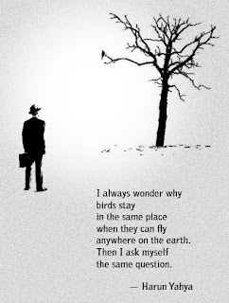](http://4.bp.blogspot.com/-t45pFOMKcyU/T2SFY4H5RtI/AAAAAAAAAxE/wqg12U-zZOc/s1600/1609301_700b_v1.jpg)

Life is about a million little things, like a universe is a million little stars. In each one of us is a microcosm that begun very much like the big bang and the universe shall end up like we all do.